Assignment #1: Introducing Events

This tutorial gives you a quick introduction to using events. You’ll make the page react to several different types of events so you can get a handle on how jQuery events work and how to use them.

1. In a text editor, open the file **index.html** in the **Introducing Events** folder.

You’ll start at the beginning by adding a link to the jQuery file.

1. Click in the empty line between the<script> tagsand add the following code:

$(document).ready(function() {

}); // end ready

Don’t forget the JavaScript comment after the });. Even though adding comments requires a little extra typing, they’ll be very helpful in identifying the different parts of a program. At this point, you’ve completed the steps you’ll follow whenever you use jQuery on your web pages.

Next, it’s time to add an event. Your first goal will be simple: have an alert box appear when a visitor double clicks anywhere on the page. To begin, you need to select the element (the page in this case) that you wish to add the event to.

1. Click in the empty line inside the **.ready()**functionand add the bolded code below:

$(document).ready(function() {

**$(“html”)**

}); // end ready

The $(“html”) selects the HTML element; basically, the entire browser window. Next, you’ll add an event.

1. Type*.dblclick(); // end double**click* after the jQuery selector so your code looks like this:

$(document).ready(function() {

$(“html”)**.dblclick(); // end double click**

}); // end ready

.dblclick() is a jQuery function that gets the browser ready to make something happen when a visitor double-clicks on the page. The only thing missing is the “make something happen” part, which requires passing an anonymous function as an argument to the dblclick() function.

1. Add an anonymous function by typing the code in bold below:

$(document).ready(function() {

$(“html”).dblclick**(function() {**

**}**); // end double click

}); // end ready

I realize this may be moving at a glacial pace, but it’s important for you to understand what each piece of the code is doing (future assignments will be quicker). The function() { } is just the outer shell; it doesn’t do anything until you add programming inside the { and }. That’s the next step.

1. Finally, add an alert statement:

$(document).ready(function() {

$(“html”).dblclick(function() {

**alert(“Ouch!”);**

}); // end double click

}); // end ready

If you preview the page in a web browser and double-click anywhere on the page, a JavaScript alert box with the word “Ouch!” should appear. If it doesn’t, double-check your typing to make sure you didn’t miss anything.

Now that you’ve got the basics, you’ll try out a few other events.

1. Add the code in bold below so your script looks like this:

$(document).ready(function() {

$(“html”).dblclick(function() {

alert(“Ouch!”);

}); // end double click

**$(“a”).mouseover(function() {**

**}); // end mouseover**

}); // end ready

This code selects all links on a page (that’s the $(“a”) part), then adds an anonymous function to the mouseover event. In other words, when someone mouses over any link on the page, something is going to happen.

1. Add two JavaScript statements to the anonymous function you added in the last step:

$(document).ready(function() {

$(“html”).dblclick(function() {

alert(“Ouch!”);

}); // end double click

$(“a”).mouseover(function() {

**var message = “<p>You moused over a link.</p>”);**

**$(“.content”).append(message);**

}); // end mouseover

}); // end ready

The first line here—var message = "<p>You moused over a link</p>";—creates a new variable named message and stores a string in it. The string represents an HTML paragraph tag with some text. The next line selects an element on the page with a class name of main (that’s the $(“.content”)) and then appends (or adds to the end of that element) the contents of the message variable. The page contains a <div> tag with the class of *content*, so this code simply adds “You moused over a link” to the end of that div each time a visitor mouses over a link on the page.

1. Save the page, preview it in a browser, and mouse over any link on the page.

Each time you mouse over a link, a paragraph is added to the page. Now you’ll add one last bit of programming: when a visitor clicks on the form button on the page, the browser will change the text that appears on that button.

1. Lastly, add the code in bold below so your finished script looks like this:

$(document).ready(function() {

$(“html”).dblclick(function() {

alert(“Ouch!”);

}); // end double click

$(“a”).mouseover(function() {

var message = “<p>You moused over a link.</p>”);

$(“.content”).append(message);

}); // end mouseover

**$(“#button”).click(function() {**

**$(this).val(“Stop that!”);**

**}); //end click**

}); // end ready

You should understand the basics here: $('#button') selects an element with the ID button (the form button in this case), and adds a click event to it, so when someone clicks the button, something happens. In this example, the words “Stop that!” appear on the button.

**$(this)** refers to the element that is responding to the event—the element you select and attach the event to. In this case, this is the form button. The jQuery **val()** function is used to read the value from or change the value of a form element. In this example, passing the string “Stop that!” to the val() function sets the button’s value to “Stop that!”).

1. Save the page, preview it in a browser, and click the form button.

The button’s text should instantly change.

For an *optional* exercise, add the programming to make the text field’s background color change to red when a visitor clicks or tabs into it. Here’s a hint: You need to (a) select the text field; (b) use the **focus()** event; (c) use **$(this)** (as in step 10) to address the text field inside the anonymous function; and (d) use the **.css()** function to change the background color of the text field.

The completed assignment should look something like this (the red text field background is optional):

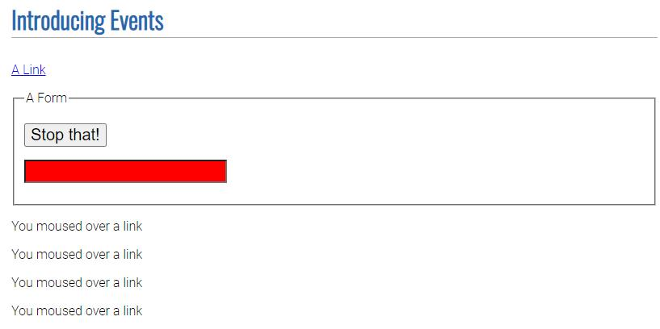

**This assignment is worth 20 points and is due on Tuesday, October 15th.**

*Please let me know if you have questions or need assistance.*